一个简单的springmvc框架写的 helloworld例子

一个简单的springmvc框架写的 helloworld例子

项目结构图

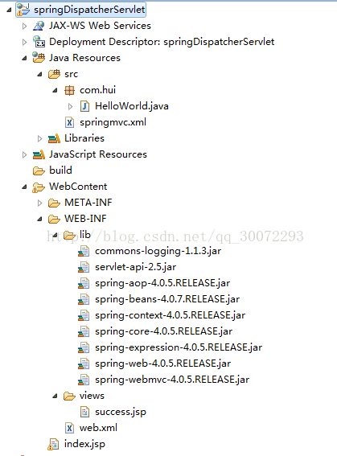

本项目，是在eclipse上写的，服务器是tomcat7.0,jdk版本1.7

1.在eclipse下创建一个dynamic web project项目

2.添加需要的jar到lib下，然后选中所有的jar包，右键 Build Path-- add to build path 如下图

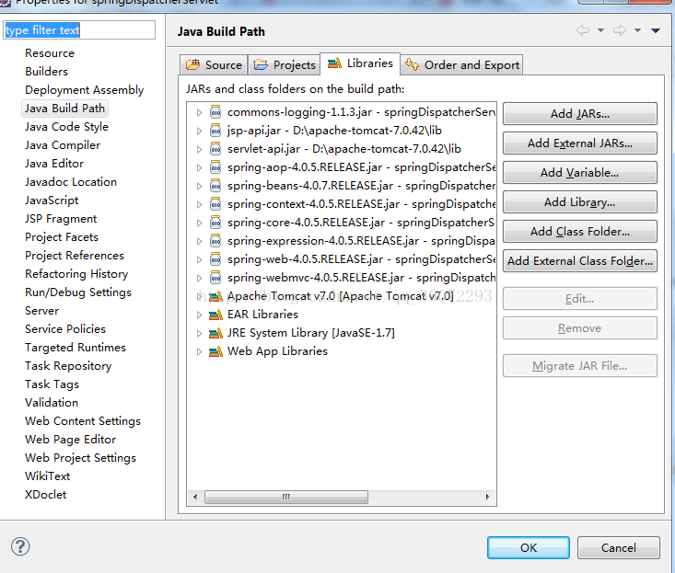

3.配置web.xml文件

<?xml version="1.0" encoding="UTF-8"?>

<web-app xmlns:xsi="http://www.w3.org/2001/XMLSchema-instance" xmlns="http://java.sun.com/xml/ns/javaee" xmlns:web="http://java.sun.com/xml/ns/javaee/web-app_2_5.xsd" xsi:schemaLocation="http://java.sun.com/xml/ns/javaee http://java.sun.com/xml/ns/javaee/web-app_2_5.xsd" id="WebApp_ID" version="2.5">

<!-- SpringMVC的前端控制器 -->

<servlet>

<servlet-name>springDispatcherServlet</servlet-name>

<servlet-class>org.springframework.web.servlet.DispatcherServlet</servlet-class>

<!-- 设置自己定义的控制器xml文件 -->

<init-param>

<param-name>contextConfigLocation</param-name>

<param-value>classpath:springmvc.xml</param-value>

</init-param>

<load-on-startup>1</load-on-startup>

</servlet>

<!-- Spring MVC配置文件结束 -->

<!-- 拦截设置 -->

<servlet-mapping>

<servlet-name>springDispatcherServlet</servlet-name>

<!-- 由SpringMVC拦截所有请求 -->

<url-pattern>/</url-pattern>

</servlet-mapping>

</web-app>

4.配置springmvc.xml文件

<?xml version="1.0" encoding="UTF-8"?>

<beans

xmlns="http://www.springframework.org/schema/beans"

xmlns:xsi="http://www.w3.org/2001/XMLSchema-instance"

xmlns:context="http://www.springframework.org/schema/context"

xmlns:mvc="http://www.springframework.org/schema/mvc"

xsi:schemaLocation="

http://www.springframework.org/schema/beans

http://www.springframework.org/schema/beans/spring-beans.xsd

http://www.springframework.org/schema/context

http://www.springframework.org/schema/context/spring-context-4.0.xsd

http://www.springframework.org/schema/mvc

http://www.springframework.org/schema/mvc/spring-mvc-4.0.xsd">

<!-- 标签将使用启动Spring MVC的注解扫描功能 -->

<context:component-scan base-package="com.hui" />

<!-- 默认的注解映射的支持 -->

<mvc:annotation-driven/>

<!-- 配置视图解析器 如何把handler 方法返回值解析为实际的物理视图 -->

<bean class="org.springframework.web.servlet.view.InternalResourceViewResolver">

<property name = "prefix" value="/WEB-INF/views/"></property>

<property name = "suffix" value = ".jsp"></property>

</bean>

</beans>

5.写HelloWorld类

package com.hui;

import javax.servlet.http.HttpServletRequest;

import javax.servlet.http.HttpServletResponse;

import org.springframework.stereotype.Controller;

import org.springframework.web.bind.annotation.RequestMapping;

import org.springframework.web.bind.annotation.RequestMethod;

import org.springframework.web.servlet.ModelAndView;

@Controller

public class HelloWorld {

@RequestMapping(value="/success", method = {RequestMethod.GET})

public ModelAndView successModel(HttpServletRequest request, HttpServletResponse reponse) {

ModelAndView mav=new ModelAndView();

request.setAttribute("message","abc");

mav.addObject("success");

return mav;

}

}

6.写index.jsp页面

<%@ page language="java" contentType="text/html; charset=UTF-8"

pageEncoding="UTF-8"%>

<!DOCTYPE html PUBLIC "-//W3C//DTD HTML 4.01 Transitional//EN" "http://www.w3.org/TR/html4/loose.dtd">

<html>

<head>

<meta http-equiv="Content-Type" content="text/html; charset=UTF-8">

<title>主页面</title>

</head>

<body>

<a href="success"><h1>hello</h1></a>

</body>

</html>

7.写success.jsp页面

<%@ page language="java" contentType="text/html; charset=UTF-8"

pageEncoding="UTF-8"%>

<!DOCTYPE html PUBLIC "-//W3C//DTD HTML 4.01 Transitional//EN" "http://www.w3.org/TR/html4/loose.dtd">

<html>

<head>

<meta http-equiv="Content-Type" content="text/html; charset=UTF-8">

<title>this is success jsp</title>

</head>

<body>

${message}

</body>

</html>

启动项目后效果图如下：

下图是个动图，点击下就是abc



---------------------

作者：听雨季节

来源：CSDN

原文：https://blog.csdn.net/qq_30072293/article/details/77478738

版权声明：本文为博主原创文章，转载请附上博文链接！